***Business Model - The Empathy Map***

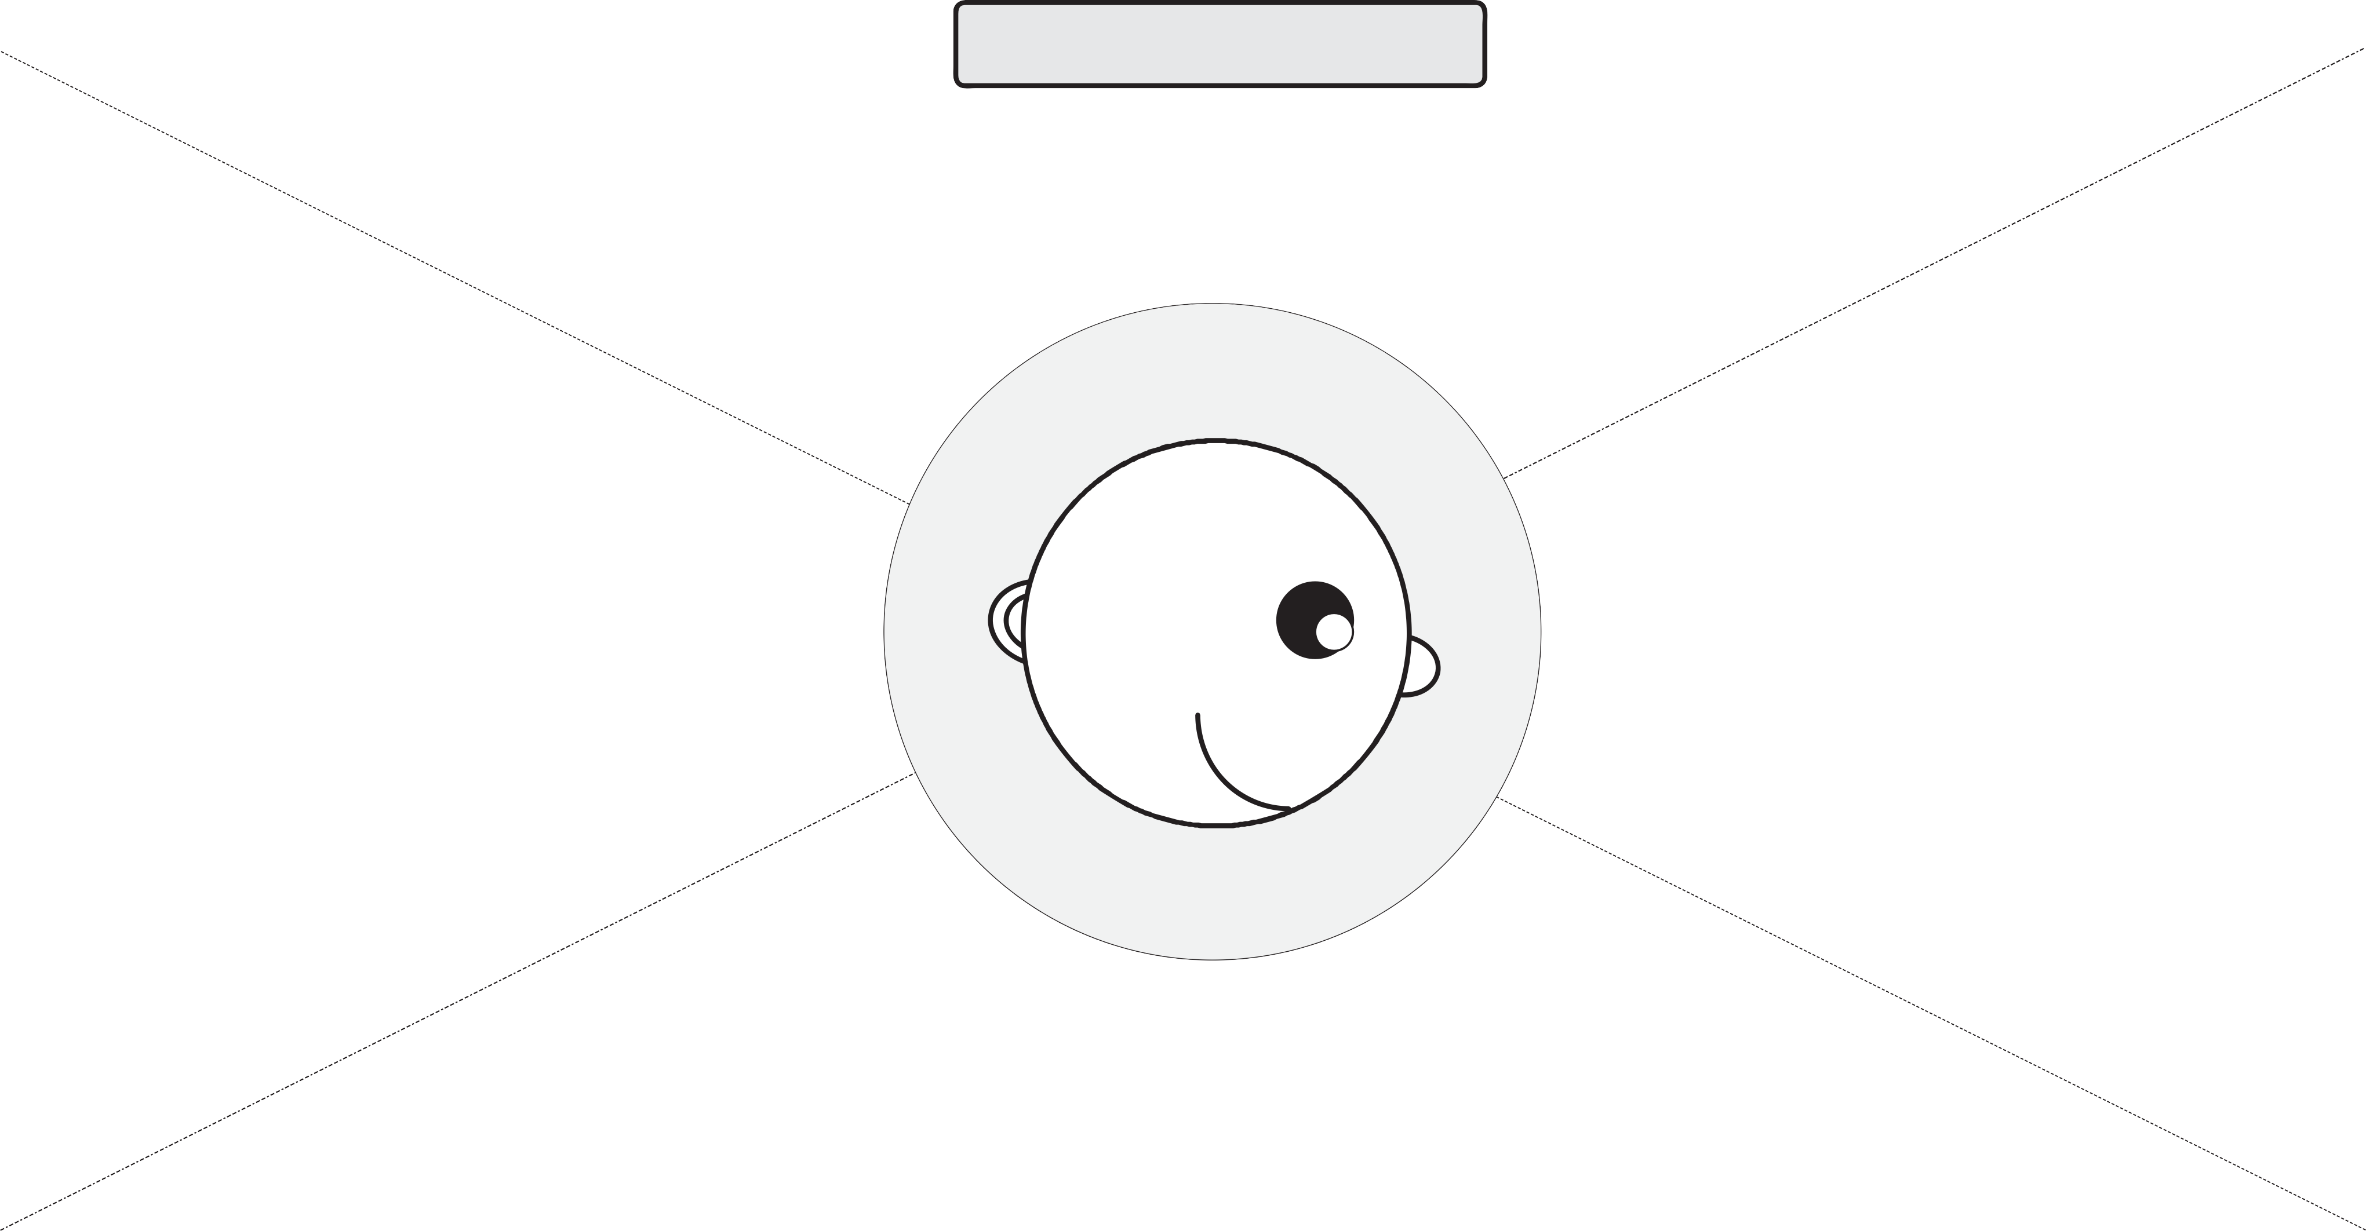

# Designed for: Design Thinking 2016 Designed by:

Customer Perspective:

Frederike Pia Lutz

# Date: Interation:

Appreciates the organization and structure of life in Singapore and the traffic system in particular

Wishes for more options to educate herself about the current state of the busyness of the trains and stations

Wishes for efficient use of the time which is available

Learnt about existing traffic apps and their helpfulness of her new friends at JCU

What does she

***THINK and FEEL?***

what really counts

major preoccupations worries & aspirations

Sees opportunities to optimize the traffic system with relatively easy means (e.g. driverless trains could operate longer to provide easy and affordable travelling options)

***HEAR?***

Heard about bus routes and options to take cabs if trains are no longer operating

what friends say

Influenced by experiences and set standards from Norway (Europe in general)

what boss says what influences say

What does she

***SEE?***

environment

friends

what the markets offers

What does she

***SAY and DO*** ?

attitude in public

appearance

Acknowledges the usability of the existing traffic apps but wishes to improve them

behavior towards others

Appears to be very time-efficient and organized

Experiences and expectations are different (Norwegian background)

Makes efficient and innovative suggestions for solutions

Despises inefficient ways of travelling

Overcrowded trains and stations cost time and nerves - unnecessary

**PAIN**

fears, frustrations, obstacles

**GAIN**

“wants”/needs, measures of success, obstacles

### Adapted from XPLANE. XPlane.com